(Approx. 209 words)

Whoosh! …
By George Harding, Treasurer, Tucson Computer Society
www.aztcs.org
georgehardingsbd (at) earthlink.net

One of the very useful products I came across at CES was Whoosh!

It is a screen-cleaning product that not only clears out all the grime and fingerprints from your phone’s screen, but also protects it from further contamination. It works on other screens, as well. I use it on my tablet and my laptop, too. I could use it on my flat
screen TV also, but haven’t yet.

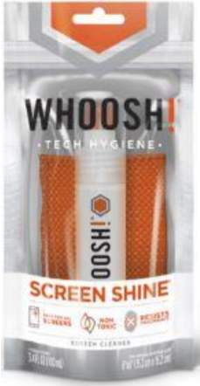
The product is a spray bottle of liquid, which is non-toxic. and a polishing cloth. You spray a bit of liquid on the cloth, wipe the surface of your screen, then use a dry part of the cloth to polish the screen to a pristine finish. The cloth has been treated with an antimicrobial product to protect the cloth from contamination.

There are several packages in the product, including packets of screen wipes, as well at the customary spray bottle and cloth packages. The latter come in three sizes. The product is available in most office supply and computer stores.

This is a great product to have at home or office. It gives you clean screens in a flash.

Whoosh!
www.whooshscreenshine.com
Price varies from $10 to $20

